**Price prediction app: Car recognition using ML**

**Group leader: Humayun Mumtaz Student 1 name: Alisha Zahid**

**Group leader roll no: 2018-SE-21 Student 1 roll no: 2018-SE-43**

**Group leader email: mumtazhumayun6@gmail.com Email: alishazahid27@gmail.com**

**Student 2 name: Ushna Aftab Ahmed khan Student 3 name: Hafiz M.Hamza**

**Student 2 roll no: 2018-SE-11 Student 3 roll no: 2018-SE-26**

**Email:** [**ushnakhan748@gmail.com**](mailto:ushnakhan748@gmail.com) **Email: hamzamuzaffar5544@gmail.com**

**25-May-2021**

1. **Motivation**

Me (Humayun Mumtaz) went to search a car in olx and other website, but according to my requirements I saw that the car prices are over crossing the price, I was totally flummoxed because of prices, then I decided that I will create an application related to car price predication, now me and my group members want to develop this app

1. **Overview**

**2.1 significance of project**

Those members like me who searches for a car and then also feel that according to their requirements car prices are over crossing the price, then don’t should they me and my team members are coming with this solution of the human problem

**2.2 description of project**

The used car market is an ever-rising industry, which has almost doubled its market value in the last few years. The emergence of online portals such as, OLX and 4Wheel and many others has facilitated the need for both the customer and the seller to be better informed about the trends and patterns that determine the value of the used car in the market. Machine Learning algorithms can be used to predict the retail value of a car, based on a certain set of features. Automated vehicle recognition and price prediction are two interesting problems encountered within the automotive industry. The ability to accurately identify a vehicle within an image is extremely useful in many areas including intelligent transport systems and autonomous driving.

The main objective of this project is to use three different prediction models to predict the retail price of a used car and compare their levels of accuracy. The data set will be used for the prediction models will be collect from experienced car dealers. The data set primarily comprises of categorical attributes along with two quantitative attributes

1. **Methodology**

**3.1 design phase**

We will say solely that this solution will be very helpful for the curious of car, because everyone wants to get the Good car than totally dead car with a good budget and with quality

**3.2 implementation phase**

After creating this app we will implement or upload on play store then we will send the link of application to our known people, and so on, after getting the feedback if anything have to changed we will change according to people requirements

**3.3 testing phase**

First of all we will get feedback from human by the application if they do complain then we will do some minor changes

**3.4 Evaluation phase:**

We will evaluate the result about our project by the questionaries we will provide some question to people and then we will collect their answers about our project this is very best solution for evaluation

1. **Features**

**Feature 1:**

After login the application customer will add the car requirement and car owner will contact with him

**Feature 2:**

By using the ML Prediction algorithm, which customer will put the requirements Algorithm will predict and will give the result related to customer’s requirements

**Feature 3:**

User can see about his profile and he can update his profile

**Feature 4:**

Fast services with according to less budget of car price

1. **Project planning**

|  |  |
| --- | --- |
| Humayun Mumtaz (Group leader) | Registration/Login with database connectivity  Home page  ML Algorithm for prediction the price |
| Alisha Zahid | Create, delete, update, delete operations functions will create  Contact with customer of client |
| Ushna Aftab Ahmed Khan | Manage user detail |
| Hafiz Muhammad Hamza | Admin system operation will create |

1. **Required hardware and software**

android phone

Software such as internet, WIFI, Application

1. **Diagrammatic Representation of the Overall System**

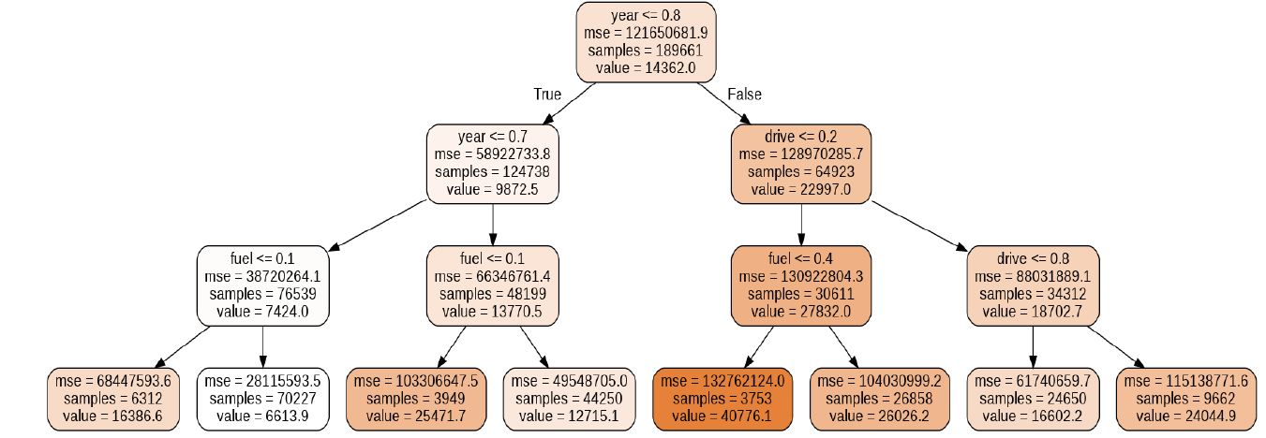

**Appendices**

**A Expected Internal Advisor**

Sir Kashif Sheikh

**B Expected External Advisor**